Recommendation Engine
(A Java-based Personalized Recommendation System)
Project Report submitted for the partial fulfilment of grade for the course

Data Structures and Algorithms -3 (25CS2103E)
in

A.Y. 2026-2027

Submitted by
Yaswanth H (2520090095)
Venu Gopal (2520090185)

Team Number: 37
Section: 12

Under the guidance of

Chandusha Kanda

Department of CSIT
Hyderabad-500090, Telangana, India.

K L (Deemed to be) University
DEPARTMENT OF COMPUTER SCIENCE AND INFORMATION TECHNOLOGY



DECLARATION

The Mini Project Report entitled “Recommendation Engine” is a record of Bonafide work of Yaswanth H – 2520090095, Venu Gopal – 2520090185 submitted in partial fulfillment for the award of B. Tech in Computer Science and Information Technology to the K L University. The results embodied in this report have not been copied from any other departments/University/Institute.

Yaswanth H – 2520090095
Venu Gopal – 2520090185

K L (Deemed to be) University
DEPARTMENT OF COMPUTER SCIENCE AND INFORMATION TECHNOLOGY
CERTIFICATE

This is to certify that the mini project based report entitled “Recommendation Engine” is a bonafide work done and submitted by Yaswanth H – 2520090095, Venu Gopal – 2520090185 in partial fulfillment of the requirements for the award of the degree of BACHELOR OF TECHNOLOGY in Department of Computer Science and Information Technology, K L (Deemed to be University), during the academic year 2026-2027.

Signature of the Supervisor

Signature of the HOD Signature of the External Examiner

ACKNOWLEDGEMENT

The success in this project would not have been possible but for the timely help and guidance rendered by many people. We wish to express our sincere thanks to all those who have assisted us in one way or the other for the completion of our project.

Our greatest appreciation goes to our guide, Chandusha Kanda, Department of Computer Science and Information Technology, whose tremendous support, encouragement and guidance for this project cannot be expressed in words.

We express our gratitude to Dr. Khaja Shareef, Head of the Department of Computer Science and Information Technology, for providing us with adequate facilities, ways and means by which we were able to complete this project-based Lab.

We thank all the members of the teaching and non-teaching staff who have assisted us directly or indirectly in the successful completion of this project. Finally, we sincerely thank our parents, friends and classmates for their kind help and cooperation during our work.

Yaswanth H – 2520090095
Venu Gopal – 2520090185

TABLE OF CONTENTS

S.No. | Contents | Page no.
1. | Abstract | 6
2. | Introduction | 7
3. | Literature survey | 8
4. | Problem Statement and Objectives | 9
5. | Hardware and Software requirements | 10
6. | Implementation | 11
7. | Results & Discussion | 15
8. | Conclusion & Future Scope | 17
9. | References | 18
1.ABSTRACT

The Recommendation Engine project presents a Java-based system that provides personalized recommendations to users by analyzing their preferences, ratings, and interactions with different items. The project demonstrates the practical application of Data Structures and Algorithms (DSA) to efficiently manage and process recommendation data. Data structures such as ArrayList, HashMap, HashSet, and Priority Queue are used to store user information, item details, preferences, and recommendation scores. Algorithms for searching, sorting, and similarity calculation are applied to identify suitable items for each user. The system analyzes user preferences and ranks available items according to their relevance, generating the most appropriate recommendations. By combining Java programming with DSA concepts, the project focuses on efficient data storage, fast retrieval, and effective ranking of results. The Recommendation Engine demonstrates how fundamental programming and algorithmic concepts can be applied to develop a practical, personalized, and efficient real-world application.
Team Name: Team 37 (Section 12)

Team Logo (if any): Not applicable

Team Members:
- Yaswanth H, 2520090095
- Venu Gopal, 2520090185

- INTRODUCTION

Today almost every digital platform – online shopping sites, video streaming services, music apps and news portals – offers more items than any user can browse. A recommendation engine helps users cope with this information overload by suggesting items that match their tastes, so that useful content is discovered quickly instead of being searched for manually [10]. Well-known examples are the “customers who bought this also bought” lists of e-commerce sites [3] and the movie suggestions of video streaming platforms [4].
The goal of this project is to build a small but complete recommendation engine in Java that is also a showcase of Data Structures and Algorithms (DSA). Users rate items on a scale of 1 to 5. From these ratings the system (i) finds users with similar tastes, (ii) finds items similar to the ones a user already likes, and (iii) combines both views into a single relevance score that is used to rank every item the user has not yet seen. This is the idea of a hybrid recommender, which combines collaborative and content-based filtering [6].
The choice of data structure decides how fast such a system is. In this project an ArrayList stores users and items in order, a HashMap gives constant-time access to ratings and scores, a HashSet keeps item tags and unique interactions, and a PriorityQueue (min-heap) selects the Top-N results without sorting the whole catalogue. Searching, sorting and similarity calculation (cosine and Jaccard) are the main algorithms applied.
The rest of this report is organised as follows: Section 3 reviews related work, Section 4 states the problem and objectives, Section 5 lists the hardware and software requirements, Section 6 presents the implementation modules, Section 7 shows the results with discussion, Section 8 concludes the work with future scope, and Section 9 lists the references.
- LITERATURE SURVEY
A study of earlier recommendation systems and research work was carried out before designing this project. The main works that influenced our design are summarised below; their links are given in the References section.
1. GroupLens – the first collaborative filtering system [2]. Resnick et al. built GroupLens, an open architecture in which Usenet readers rate articles and receive predictions based on the ratings of like-minded readers. It established user-based collaborative filtering, the technique used for the similarity module of this project.
2. Item-based collaborative filtering [1]. Sarwar et al. showed that similarities between items change more slowly than similarities between users, so they can be pre-computed and looked up quickly. Their study compared cosine, correlation and adjusted-cosine measures and demonstrated better scalability than user-based methods.
3. Amazon.com item-to-item recommendations [3]. Linden, Smith and York described how Amazon scales recommendations to millions of customers and items by building a similar-items table offline. The online step only has to look up and rank a few related items, which inspired our use of hash-based lookup and Top-N ranking.
4. Matrix factorization and the Netflix Prize [4]. Koren, Bell and Volinsky explain the latent-factor models that dominated the Netflix Prize competition. Users and items are mapped to a small number of hidden factors, which gives high accuracy and compact storage, but it needs heavier mathematics than a basic DSA-oriented engine.
5. Content-based recommendation [5]. Pazzani and Billsus describe systems that recommend items whose attributes (keywords, genres, tags) resemble items the user liked earlier. These systems work even for new items with no ratings, which is why our engine also uses a tag-based Jaccard similarity.
6. Hybrid recommender systems [6]. Burke surveys and tests ways of combining collaborative and content-based methods – weighted, switching, cascade and others – and shows that hybrids reduce the cold-start and sparsity problems of single methods. We use the weighted hybrid, score = α·CF + (1−α)·CB.
7. MovieLens data sets [7]. Harper and Konstan document the MovieLens rating data sets released by the GroupLens research group, the standard benchmark for recommender projects. Our sample data follows the same user–item–rating format, so a real MovieLens file can be loaded later.
8. LensKit toolkit [8]. LensKit is an open-source Java toolkit for building and evaluating recommender algorithms. It shows how recommendation code can be structured into data access, similarity and ranking components, the same modular approach followed in this project.
- Problem Statement and Objectives

Problem Statement:
Users cannot manually search through very large item catalogues, so a fast and efficient system is needed that suggests the most relevant items for each user.

Problem Description:
Recommendations must be generated from sparse user ratings and item details without scanning and sorting all the data again for every request; the system must choose suitable data structures and algorithms for storage, similarity calculation and ranking.
Objectives:
The project was initiated to show how fundamental DSA concepts solve a real-world problem – information overload – and its objectives are:
- To design a Java-based recommendation engine that provides personalized recommendations to each user from preferences and ratings.
- To apply data structures – ArrayList, HashMap, HashSet and PriorityQueue – for efficient storage and fast retrieval of user, item and score data.
- To implement similarity algorithms (cosine similarity between users and Jaccard similarity between items) to match user preferences with items.
- To combine collaborative and content-based scores into a hybrid relevance score and rank the unseen items by it.
- To generate the Top-N recommendations efficiently using a min-heap, and to provide keyword search over the catalogue.
- HARDWARE AND SOFTWARE REQUIREMENTS
Hardware Requirements:
- Processor: Intel Core i5 or equivalent
- RAM: 4 GB minimum
- Storage: 500 MB free disk space
Software Requirements:
- Language / Runtime: Java Development Kit (JDK) 8 or higher
- IDE: Eclipse or IntelliJ IDEA
- Build tool: Maven or Gradle
- Operating system: Windows 10/11, Linux or macOS
- IMPLEMENTATION

The system is implemented in Java using the standard Collections framework [9] and is divided into four modules. The complete source code is given below.
Module 1: Data Models (User.java and Item.java)
A User keeps its ratings in a HashMap (itemId → rating) so that any rating can be read in O(1). An Item keeps its tags in a HashSet, which removes duplicates and supports fast set operations for similarity.
import java.util.*;

/** Module 1a: a user and the ratings they have given. */
public class User {
private final int id;
private final String name;
// itemId -> rating (1.0 - 5.0)
private final Map<Integer, Double> ratings = new HashMap<>();

public User(int id, String name) { this.id = id; this.name = name; }

public int getId() { return id; }
public String getName() { return name; }
public Map<Integer, Double> getRatings() { return ratings; }

public void rate(int itemId, double rating) { ratings.put(itemId, rating); }
public boolean hasRated(int itemId) { return ratings.containsKey(itemId); }
}

import java.util.*;

/** Module 1b: an item (movie) with a category and a set of tags. */
public class Item {
private final int id;
private final String title;
private final String category;
private final Set<String> tags = new HashSet<>();

public Item(int id, String title, String category, String... tagList) {
this.id = id;
this.title = title;
this.category = category;
tags.addAll(Arrays.asList(tagList));
}

public int getId() { return id; }
public String getTitle() { return title; }
public String getCategory() { return category; }
public Set<String> getTags() { return tags; }
}

Module 2: Data Store (DataStore.java)
All users and items are stored in ArrayLists (ordered, iterable) and indexed with HashMaps, so a user or item can be fetched by its id in O(1). The loadSample() method creates the demo data set of 5 users, 10 movies and 25 ratings.
import java.util.*;

/** Module 2: stores users and items using ArrayList and HashMap. */
public class DataStore {
private final List<User> users = new ArrayList<>();
private final List<Item> items = new ArrayList<>();
private final Map<Integer, User> userIndex = new HashMap<>();
private final Map<Integer, Item> itemIndex = new HashMap<>();

public void addUser(User u) { users.add(u); userIndex.put(u.getId(), u); }
public void addItem(Item i) { items.add(i); itemIndex.put(i.getId(), i); }

public User getUser(int id) { return userIndex.get(id); } // O(1)
public Item getItem(int id) { return itemIndex.get(id); } // O(1)
public List<User> getUsers() { return users; }
public List<Item> getItems() { return items; }

/** Loads a small sample data set. */
public static DataStore loadSample() {
DataStore ds = new DataStore();
String[][] movies = {
{"Inception", "SciFi", "thriller", "mind-bending", "space"},
{"Interstellar", "SciFi", "space", "drama", "mind-bending"},
{"The Matrix", "SciFi", "action", "mind-bending", "cyber"},
{"Avengers", "Action", "action", "superhero", "team"},
{"Dark Knight", "Action", "action", "superhero", "thriller"},
{"Titanic", "Romance", "romance", "drama", "history"},
{"The Notebook", "Romance", "romance", "drama", "love"},
{"Hera Pheri", "Comedy", "comedy", "classic", "fun"},
{"3 Idiots", "Comedy", "comedy", "drama", "college"},
{"Gravity", "SciFi", "space", "thriller", "survival"}
};
for (int i = 0; i < movies.length; i++) {
String[] m = movies[i];
ds.addItem(new Item(i + 1, m[0], m[1], Arrays.copyOfRange(m, 2, m.length)));
}
String[] names = {"Yaswanth", "Venu", "Anil", "Priya", "Sneha"};
for (int i = 0; i < names.length; i++) ds.addUser(new User(i + 1, names[i]));

int[][] r = { // userId, itemId, rating
{1,1,5},{1,2,5},{1,3,4},{1,4,3},{1,6,2},
{2,1,5},{2,2,4},{2,3,5},{2,10,4},{2,8,2},
{3,4,5},{3,5,5},{3,3,4},{3,9,3},{3,6,1},
{4,6,5},{4,7,5},{4,9,4},{4,2,3},{4,1,2},
{5,8,5},{5,9,5},{5,7,3},{5,4,2},{5,5,2}
};
for (int[] x : r) ds.getUser(x[0]).rate(x[1], x[2]);
return ds;
}
}

Module 3: Similarity Calculation (Similarity.java)
Cosine similarity compares two users over the items both have rated; Jaccard similarity (|A∩B| / |A∪B|) compares the tag sets of two items using HashSet intersection and union.
import java.util.*;

/** Module 3: similarity calculations. */
public class Similarity {

/** Cosine similarity between two users over the items both have rated. */
public static double cosine(User a, User b) {
double dot = 0, na = 0, nb = 0;
for (Map.Entry<Integer, Double> e : a.getRatings().entrySet()) {
Double rb = b.getRatings().get(e.getKey());
if (rb != null) { // common item
dot += e.getValue() * rb;
na += e.getValue() * e.getValue();
nb += rb * rb;
}
}
if (na == 0 || nb == 0) return 0;
return dot / (Math.sqrt(na) * Math.sqrt(nb));
}

/** Jaccard similarity between the tag sets of two items. */
public static double jaccard(Item a, Item b) {
Set<String> inter = new HashSet<>(a.getTags());
inter.retainAll(b.getTags());
Set<String> union = new HashSet<>(a.getTags());
union.addAll(b.getTags());
return union.isEmpty() ? 0 : (double) inter.size() / union.size();
}
}

Module 4: Recommendation Engine (Recommender.java)
Collaborative scores are a similarity-weighted average of other users’ ratings; content scores use tag similarity to items the user liked (rating ≥ 4). The two are combined as α·CF + (1−α)·CB. A min-heap PriorityQueue of size N keeps only the best N items, giving O(m log N) time instead of the O(m log m) of a full sort. A linear search method finds items by title keyword. The driver class Main.java loads the data, calls these methods and prints the output shown in Section 7.
import java.util.*;

/** Module 4: hybrid recommender (collaborative + content-based).
* A PriorityQueue (min-heap) is used to pick the Top-N items. */
public class Recommender {

/** A recommendation: item + score. */
public static class Result {
public final Item item;
public final double score;
public Result(Item item, double score) { this.item = item; this.score = score; }
}

private final DataStore store;
public Recommender(DataStore store) { this.store = store; }

/** Collaborative filtering: similarity-weighted average of other users' ratings. */
public Map<Integer, Double> collaborativeScores(User target) {
Map<Integer, Double> num = new HashMap<>();
Map<Integer, Double> den = new HashMap<>();
for (User other : store.getUsers()) {
if (other.getId() == target.getId()) continue;
double sim = Similarity.cosine(target, other);
if (sim <= 0) continue;
for (Map.Entry<Integer, Double> e : other.getRatings().entrySet()) {
int itemId = e.getKey();
if (target.hasRated(itemId)) continue; // only unseen items
num.merge(itemId, sim * e.getValue(), Double::sum);
den.merge(itemId, sim, Double::sum);
}
}
Map<Integer, Double> scores = new HashMap<>();
for (int id : num.keySet()) scores.put(id, num.get(id) / den.get(id));
return scores;
}

/** Content-based filtering: tag similarity to items the user rated 4 or above. */
public Map<Integer, Double> contentScores(User target) {
Map<Integer, Double> scores = new HashMap<>();
for (Item cand : store.getItems()) {
if (target.hasRated(cand.getId())) continue;
double sum = 0; int count = 0;
for (Map.Entry<Integer, Double> e : target.getRatings().entrySet()) {
if (e.getValue() >= 4) {
sum += Similarity.jaccard(cand, store.getItem(e.getKey()));
count++;
}
}
// scale the average tag similarity to the 0-5 rating range
if (count > 0) scores.put(cand.getId(), 5.0 * sum / count);
}
return scores;
}

/** Top-N using a min-heap of size N : O(m log N). */
public List<Result> recommend(int userId, int topN, double alpha) {
User target = store.getUser(userId);
Map<Integer, Double> cf = collaborativeScores(target);
Map<Integer, Double> cb = contentScores(target);

Set<Integer> candidates = new HashSet<>(cf.keySet());
candidates.addAll(cb.keySet());

PriorityQueue<Result> heap =
new PriorityQueue<>(Comparator.comparingDouble(r -> r.score));
for (int id : candidates) {
double s = alpha * cf.getOrDefault(id, 0.0)
+ (1 - alpha) * cb.getOrDefault(id, 0.0);
heap.offer(new Result(store.getItem(id), s));
if (heap.size() > topN) heap.poll(); // drop the lowest score
}
List<Result> out = new ArrayList<>(heap);
out.sort((x, y) -> Double.compare(y.score, x.score)); // highest first
return out;
}

/** Linear search of the catalogue by title keyword. */
public List<Item> search(String keyword) {
List<Item> found = new ArrayList<>();
for (Item i : store.getItems())
if (i.getTitle().toLowerCase().contains(keyword.toLowerCase()))
found.add(i);
return found;
}
}

- RESULTS & DISCUSSION
The program was compiled and executed with JDK 21; the screenshots below show the actual console output for the sample data set (hybrid weight α = 0.6, Top-N = 3).
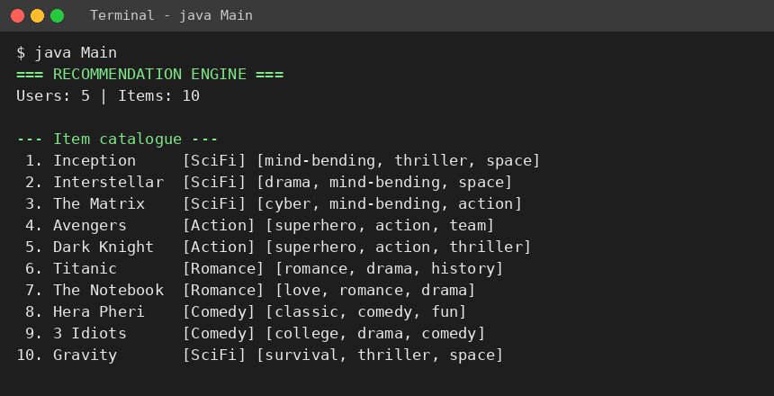
Fig. 1: Application start-up and item catalogue
The program starts, loads 5 users and 10 items, and prints the catalogue with each item’s category and tag set (stored in a HashSet).
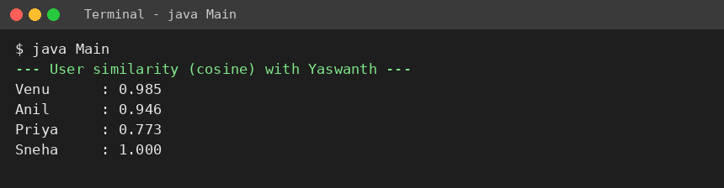
Fig. 2: User similarity (cosine) with Yaswanth
Cosine similarity is calculated between Yaswanth and every other user using the commonly rated items. Venu (0.985) and Anil (0.946) are close in taste; Priya (0.773) is the least similar.
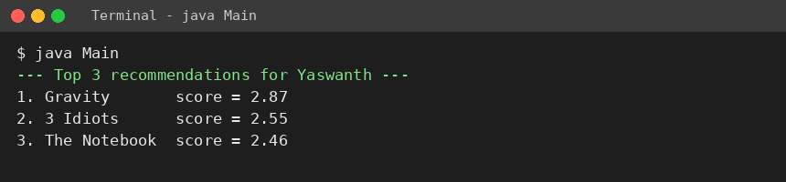
Fig. 3: Top-3 recommendations for Yaswanth
Yaswanth likes sci-fi space movies, so the hybrid score ranks Gravity first (2.87), followed by 3 Idiots and The Notebook. Movies he has already rated are excluded.
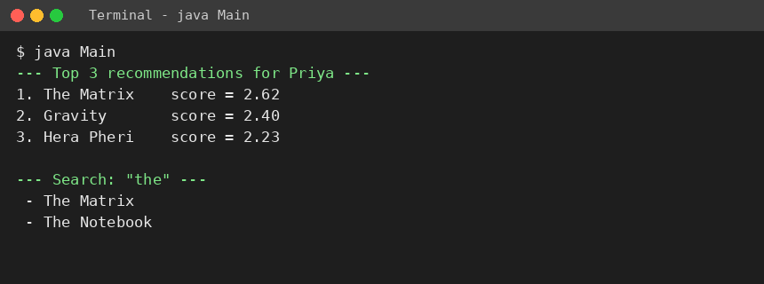
Fig. 4: Top-3 recommendations for Priya and keyword search
For Priya, who likes romance and comedy, the engine suggests The Matrix, Gravity and Hera Pheri. Searching “the” returns The Matrix and The Notebook using a linear search.
Discussion
The engine produced sensible results: users with similar ratings were found by cosine similarity, already-rated items were excluded, and the heap returned the highest-scoring items first. Lookups use HashMaps (O(1)), and Top-N selection costs O(m log N) for m candidate items.
One limitation was observed: Sneha has only one movie in common with Yaswanth, so their cosine similarity is 1.000 even though their tastes differ. Cosine similarity on very few co-rated items is therefore unreliable; this can be improved by requiring a minimum number of common items or by mean-centering the ratings (see Future Scope).
- CONCLUSION & FUTURE SCOPE
The Recommendation Engine met its objectives. A Java system was built that stores users, items and ratings in ArrayList, HashMap and HashSet structures, calculates cosine and Jaccard similarity, combines collaborative and content-based scores into one relevance score, and uses a PriorityQueue to return the Top-N recommendations for each user, along with a keyword search. The sample run confirmed that personalized and relevant items are ranked first, and that efficient data structures give fast retrieval and ranking.

Future Scope
Near term
- Load real data sets such as MovieLens [7] from CSV files instead of the built-in sample data.
- Add a minimum co-rated item count and mean-centered (Pearson-style) similarity to avoid misleading similarities.
- Add a console menu or simple GUI for adding users, items and ratings.
Medium term
- Pre-compute and cache item–item similarity (item-based filtering [1]) to speed up recommendations for large catalogues.
- Store data in a database and expose the engine as a REST service or web application.
- Evaluate accuracy with RMSE, precision@N and recall@N and tune the hybrid weight α.
Long term
- Move to matrix factorization or machine-learning models [4] and handle the cold-start problem for new users.
- Add real-time updates from user clicks and views, and scale the system with distributed processing.
- REFERENCES

[1] Sarwar, B., Karypis, G., Konstan, J., Riedl, J. (2001). Item-based collaborative filtering recommendation algorithms. Proc. 10th International World Wide Web Conference (WWW10). https://doi.org/10.1145/371920.372071
[2] Resnick, P., Iacovou, N., Suchak, M., Bergstrom, P., Riedl, J. (1994). GroupLens: An open architecture for collaborative filtering of netnews. Proc. ACM CSCW ’94. https://doi.org/10.1145/192844.192905
[3] Linden, G., Smith, B., York, J. (2003). Amazon.com recommendations: Item-to-item collaborative filtering. IEEE Internet Computing, 7(1), 76–80. https://doi.org/10.1109/MIC.2003.1167344
[4] Koren, Y., Bell, R., Volinsky, C. (2009). Matrix factorization techniques for recommender systems. IEEE Computer, 42(8), 30–37. https://doi.org/10.1109/MC.2009.263
[5] Pazzani, M. J., Billsus, D. (2007). Content-based recommendation systems. In The Adaptive Web, LNCS 4321, Springer. https://doi.org/10.1007/978-3-540-72079-9_10
[6] Burke, R. (2002). Hybrid recommender systems: Survey and experiments. User Modeling and User-Adapted Interaction, 12(4), 331–370. https://doi.org/10.1023/A:1021240730564
[7] Harper, F. M., Konstan, J. A. (2015). The MovieLens datasets: History and context. ACM Transactions on Interactive Intelligent Systems, 5(4). https://doi.org/10.1145/2827872 (data: https://grouplens.org/datasets/movielens/)
[8] LensKit – open-source toolkit for recommender systems research (Java). https://lenskit.org
[9] Oracle. Java Platform SE API documentation: PriorityQueue, HashMap, HashSet, ArrayList. https://docs.oracle.com/en/java/javase/21/docs/api/java.base/java/util/PriorityQueue.html
[10] Recommender system – overview. Wikipedia. https://en.wikipedia.org/wiki/Recommender_system

